**Gmail Request Node**

**Introduction:**

You can use the Gmail Request node in a message flow to connect to Gmail and issue requests to send, delete, or retrieve emails, or update email labels.

The Gmail Request node operations are synchronous and non-transactional, which means that, if a message flow fails and rolls back after the Gmail Request node, the operation on the data source will still complete.

**Procedure:**

The flow is driven by an HTTP input containing any well-formed JSON data, and uses a FlowOrder node to first acknowledge the input by echoing the same data back to the requesting client. Second in the flow sequence, the Gmail Request node communicates with Gmail. This node has its three output terminals (Failure, Out and NoData) wired to three separate Trace nodes to capture the results**.**

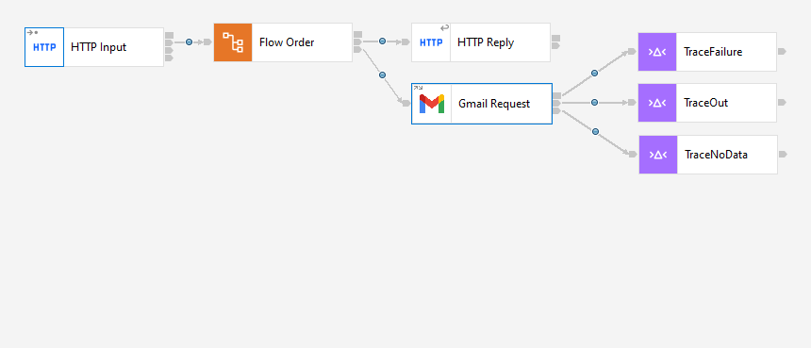

In the Input Message Parsing property select the message domain as JSON.

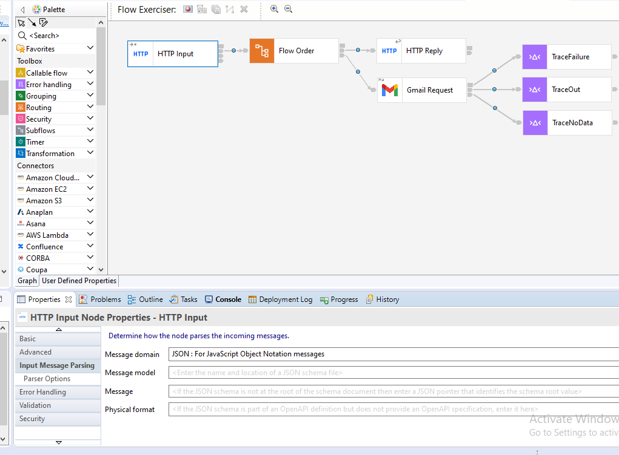

Create a local integration server in your Toolkit.

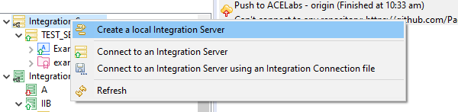

Provide the name for Integration server and give the Vault Key. And click on Finish.

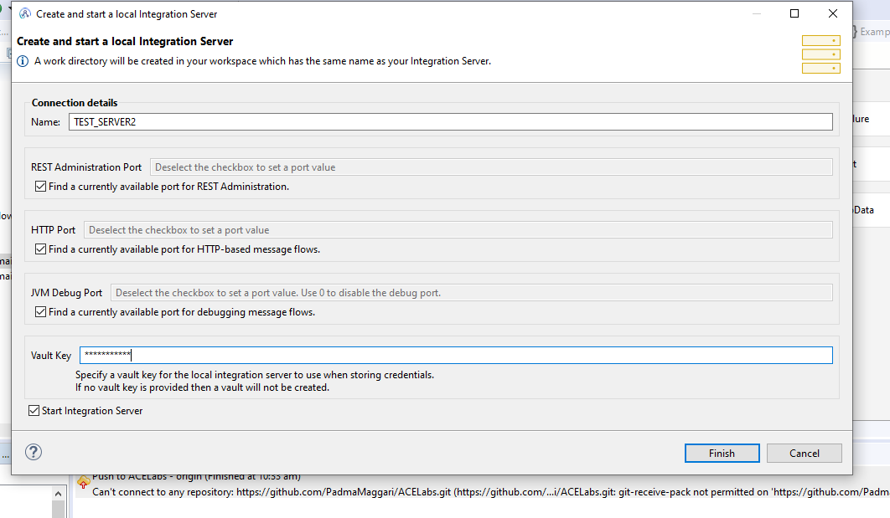

Go the Connection Property of Gmail request node give the Policy Project name by clicking on New Tab.

Provide the Integration Server work directory and Vault Key and click on Launch Discovery.

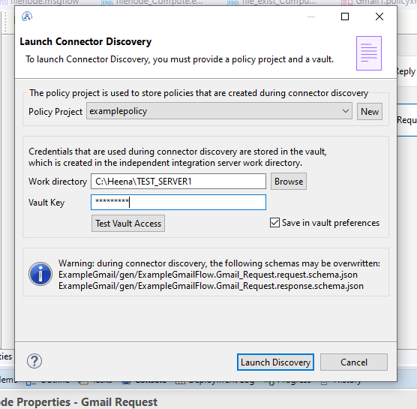

After that Connection Discovery page will be open saying that gmail not Connected.

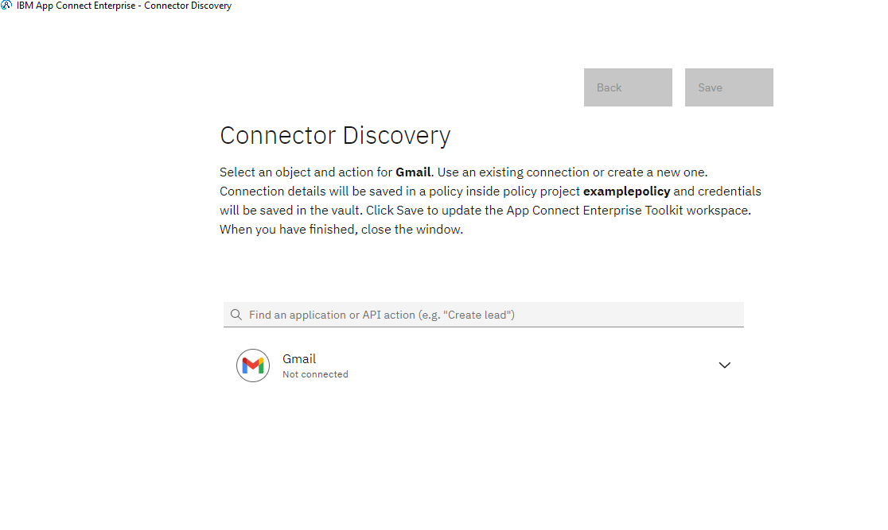

From the drop down select what kind of operation you want to perform.

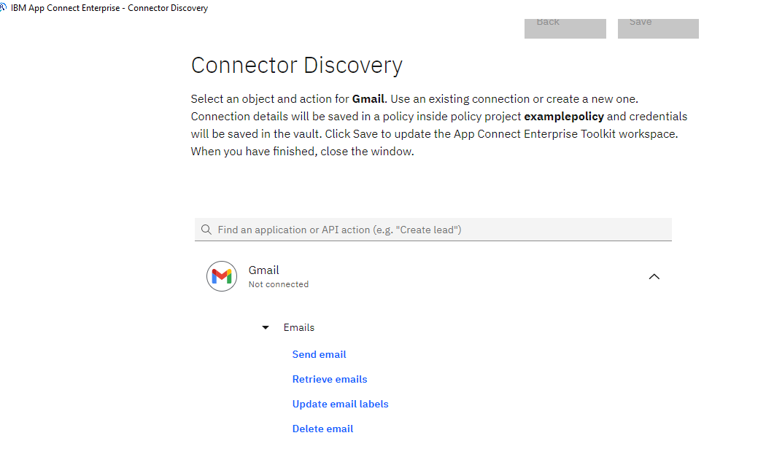

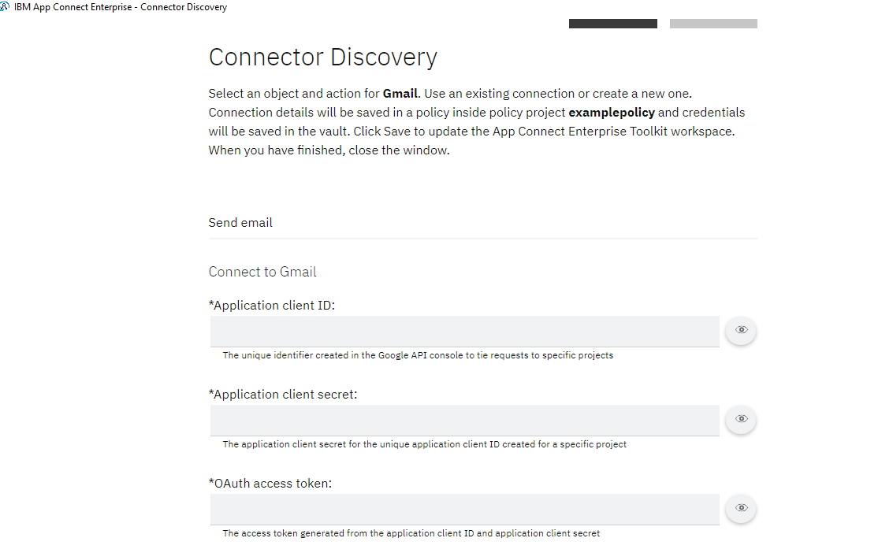

To fill the above details go through the below link.

[Getting OAuth client ID, client secret, access token, and refresh token for Google applications - IBM Documentation](https://www.ibm.com/docs/en/app-connect/container?topic=gmail-connecting-google-application-by-providing-credentials-app-connect-use-basic-oauth" \l "topicID1__oauthtokens__title__1)

After providing the above details below page will be open . Click on save.

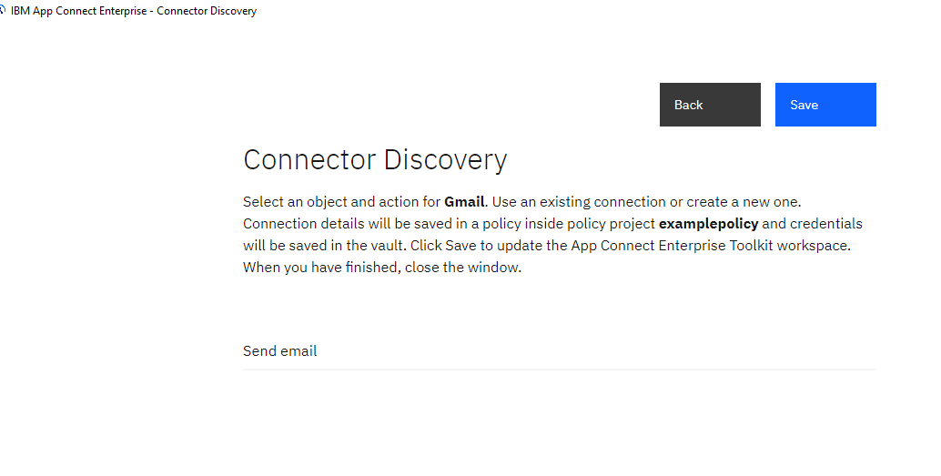

Come back to Toolkit and save the Application.

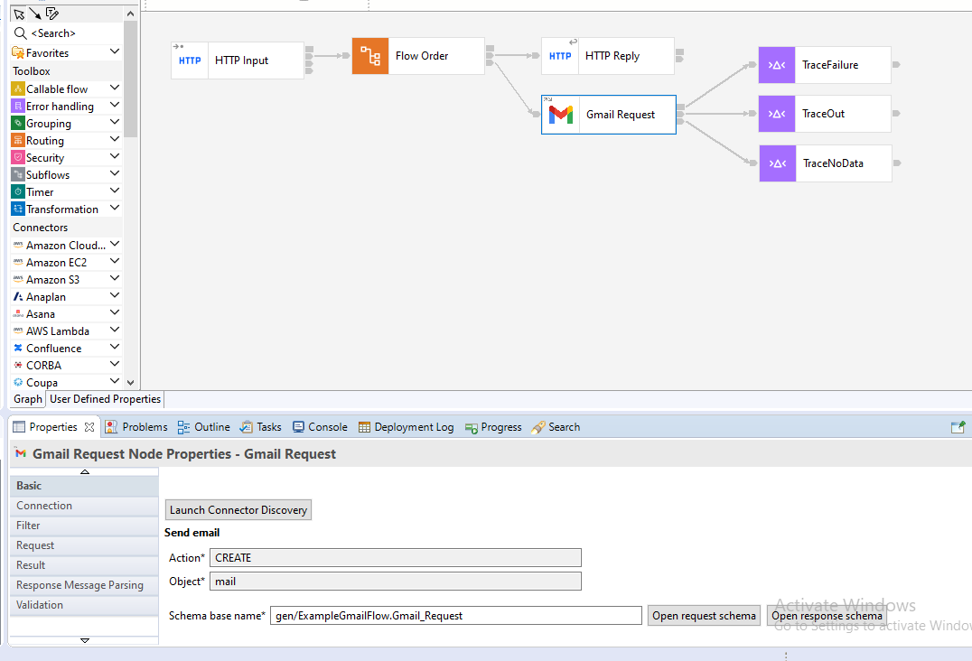

The three terminals of gmail request node connected to three trace nodes to store the logs.

For the trace node provide file path where you want to store the logs.

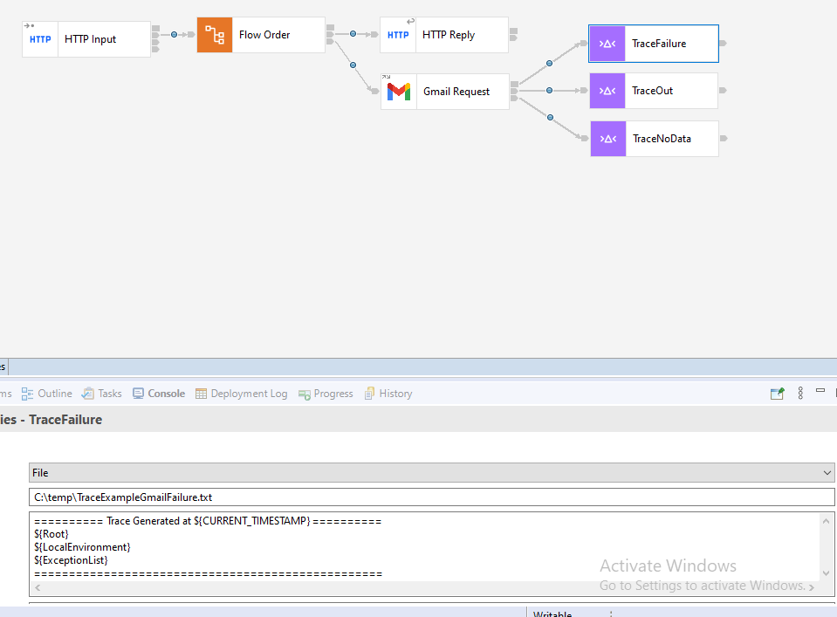

After setting all the properties start the Integration server and deploy the policy and application.

Test the Application in postman.

